MLLM Evaluation
Comparison with Multimodal Large Language Models. We further evaluate the localization capabilities of four state-of-the-art MLLMs, namely ChatGPT-5.4, Claude-4.6-Sonnet, Gemini-3.1-Pro, and Qwen3-VL, on the three datasets. Following a structured prompt design (including task instructions and visual guidance), these models are required to output normalized coordinates of the clinical targets. As summarized in Table 1 all evaluated MLLMs underperform relative to the proposed EndoKeyAnchor framework across all datasets. Among the compared MLLMs, Qwen3-VL achieves the best performance on the Phantom and Bleeding datasets, obtaining MAE values of 0.0892 and 0.0945, respectively, while ChatGPT-5.4 yields the lowest MAE on the Papilla dataset at 0.0748. However, the localization errors of these general-purpose MLLMs still remain higher than those of our method (0.0180, 0.0205, and 0.0226). Overall, these results indicate that current MLLMs, despite their strong general vision-language capabilities, are not yet sufficient for the high-precision demands of target localization without task-specific adaptation. By incorporating explicit geometric priors, our framework narrows this spatial precision gap.

Table1:Performance comparison with representative Multimodal Large Language Models (MLLMs) across three datasets. Since all MLLMs are required to output a coordinate for every test image, only overall localization errors are reported. $MAE \downarrow$ and $RMSE \downarrow$ denote the average normalized localization error and root mean square error over all test samples, respectively. The best results are highlighted in bold, and the second-best are underlined.
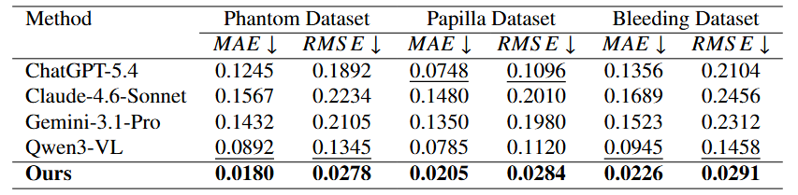
We also conducted a comparison with the general-purpose Multimodal Large Language Models (MLLMs) for target localization. Following the structured prompt design illustrated in Fig.1, each MLLM is instructed to localize the clinical target based on task instructions, visual guidance, and constrained output formatting. To improve interpretability and reduce ambiguity, the prompt explicitly specifies the clinical context, target definition, and coordinate output requirements. Since MLLMs may internally resize or preprocess input images during inference, we require them to output normalized coordinates, which are subsequently mapped back to the original image resolution for visualization and evaluation. Fig.1 presents representative examples from two localization tasks, namely papilla orifice localization and bleeding point localization. The predictions of ChatGPT-5.4, Claude-4.6-Sonnet, Gemini-3.1-Pro, and Qwen3-VL are compared against the ground truth. As shown in the figure, although some MLLMs can produce roughly plausible target estimates in relatively clear cases, their outputs often exhibit substantial spatial deviation in clinically challenging scenes. In particular, these models tend to be distracted by visually salient regions, anatomical ambiguities, specular reflections, or blood diffusion patterns, leading to inaccurate or unstable localization. Among the compared models, Qwen3-VL generally provides the most reasonable predictions, yet its outputs remain noticeably less precise than those required for reliable guidance. In contrast, our EndoKeyAnchor framework achieves more accurate and spatially consistent localization. These qualitative observations are aligned with the quantitative results in Table 1, further suggesting that current MLLMs remain insufficient for high-precision target localization without dedicated task-specific adaptation.
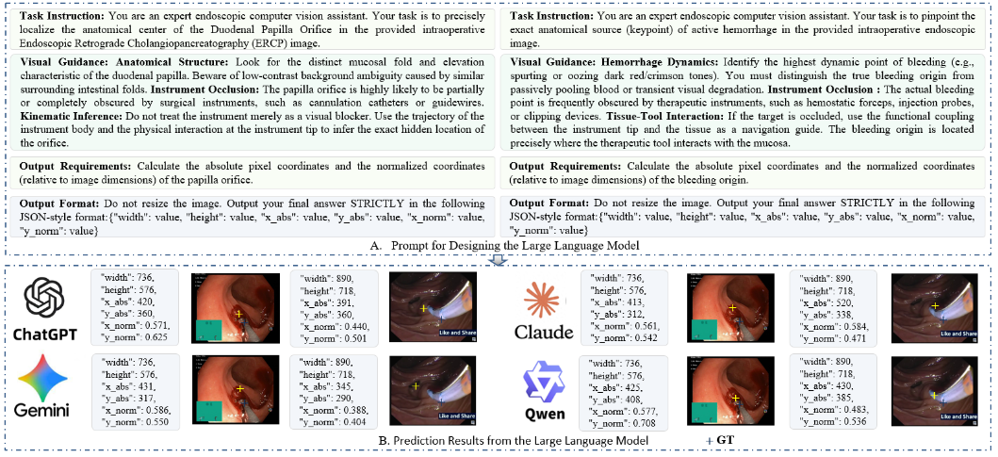
Fig1 Comparison of MLLM predictions for two endoscopic localization tasks. (A) Task prompt and visual guidance provided to the models. (B) Representative input frames from the two localization tasks.

MLLM Evaluation Protocol
This document provides the model identifiers, access interfaces, evaluation dates, prompts, inference configurations, and query counts for the exploratory multimodal large language model (MLLM) evaluation associated with EndoKeyAnchor.

1. Model Versions and Access Interfaces
The following configurations are provided as a candidate specification for documenting the four evaluated MLLMs.
Model | Access interface | Candidate API model identifier | Evaluation date
ChatGPT-5.4 | OpenAI API | gpt-5.4-2026-03-05 | 2026-03-15
Claude-4.6-Sonnet | Anthropic API | claude-sonnet-4-6 | 2026-03-15
Gemini-3.1-Pro | Google Gemini API | gemini-3.1-pro-preview | 2026-03-15
Qwen3-VL | Alibaba Cloud Model Studio API | qwen3-vl-plus-2025-12-19 | 2026-03-15

2. Complete Evaluation Prompts
The evaluation is designed as a frame-wise target localization task. Each query contains one endoscopic frame and a task-specific instruction. The model is requested to return the target location as normalized image coordinates.

3. Inference and Decoding Parameters
Parameter | ChatGPT-5.4 | Claude-4.6-Sonnet | Gemini-3.1-Pro | Qwen3-VL
Temperature | 0.0 | 0.0 | 1.0 | 0.1
Top-p | 1.0 | 1.0 | 1.0 | 1.0
Maximum output tokens | 256 | 256 | 256 | 256
Queries per sample | 1 | 1 | 1 | 1
Test-time fine-tuning | None | None | None | None
Output format | JSON coordinates | JSON coordinates | JSON coordinates | JSON coordinates

4. Query Counts and Evaluation Procedure
The example protocol uses one independent model query per test image. Each query contains the task instruction and the corresponding endoscopic frame. No ground-truth coordinate is provided as part of the input.
Under this example configuration, no additional test-time refinement or repeated-query averaging is performed. The first valid response is used as the predicted target coordinate.

